How do I add my MP3 file created with Audacity to my PowerPoint project?

- Have your PowerPoint project open
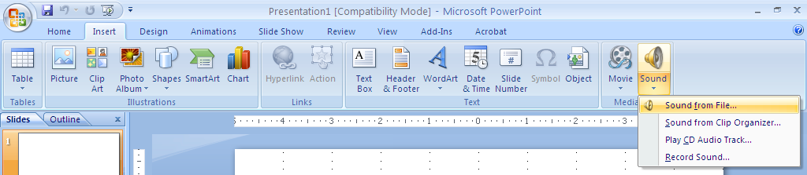
- In the “insert” tab choose “sound”, then from the pop-up menu, “Sound from File”

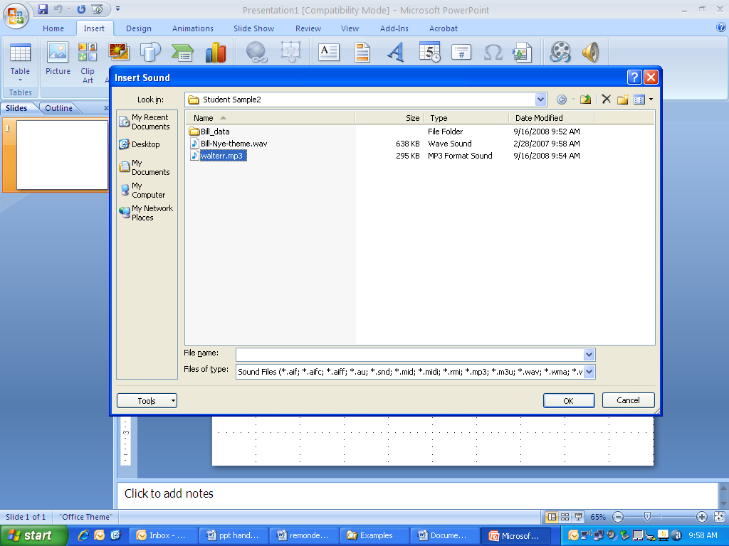
- Locate your file and tell the dialog box “okay”. A dialog box will ask how you want to play the slides. Choose “automatically”

- A small speaker will appear in your slide
- You should be in the menu that shows options for your sound file
- Click “Hide During Show” (hides your speaker while playing the show)
- Pull down the “Play Sound” menu and choose “Play across slides” (plays during entire show)
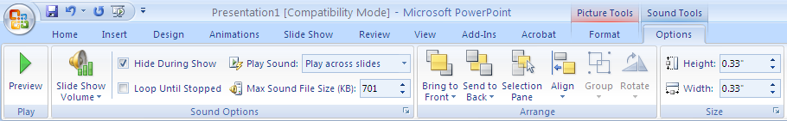

- Go to the Slide Show tab and click on rehearse timings. Your slide show will run and allow you to choose the amount of time each slide will appear on the screen. You will also see how long the entire show will run.
